Contemporaneous Notes

Examiner | Alish Mahat (23000965) | Exam commenced | 30/12/2025
Other relevant information |  | Software used, versions and licensing | Autopsy (4.21.0)  Regripper(4.0)  AcessData FTK imager (3.1.2.0)
Note: This document forms the scope of your investigation, the Officer In Charge wants these areas examined. If you decide to omit a process, then you should provide your reasons for doing so here and in your statement. You may add additional rows, as appropriate.

Action | Done? | Date | Time | Notes
Load case and verify image | Yes | 30/12/2025 | 6:15 AM | 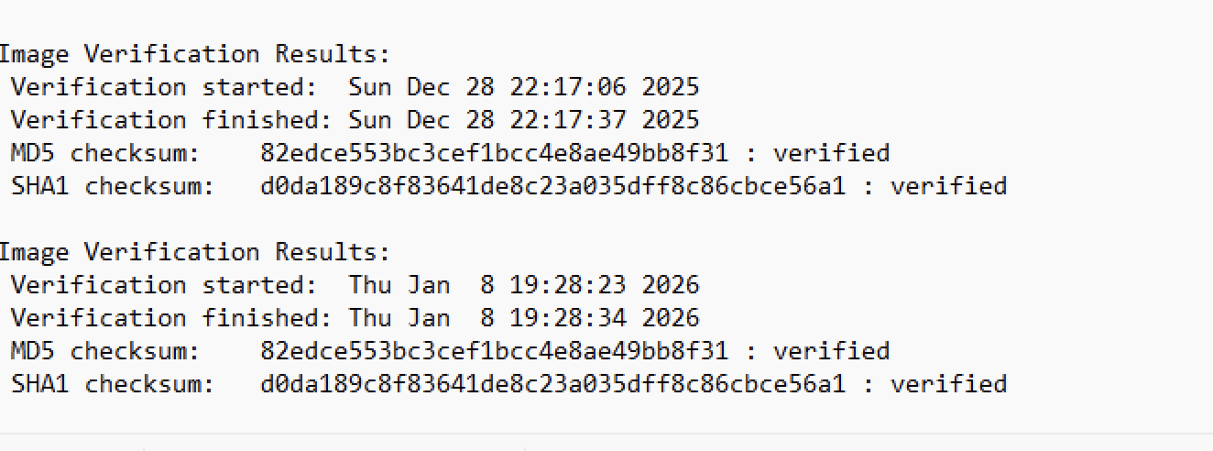  First took a look at hash which came with the e01 file and then  Autopsy > New Case >load image. Set timezone. Verified MD5/SHA hash using 'Data Source Integrity' module.  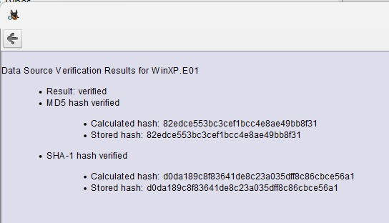
Load Case into second forensic tool for dual verification of at least 2 key artefacts, evidence items | Yes | 30/12/2025 | 6:20 AM | 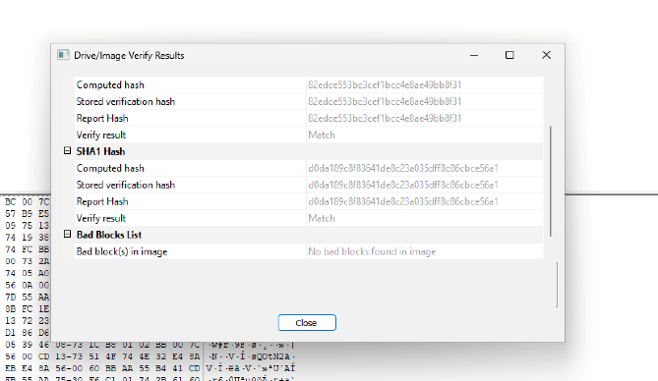  using AcessData FTK imager to matched hash value and MD5.  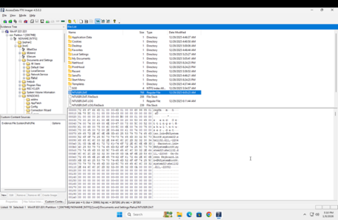  - Utilized FTK Imager to examine the NTUSER.DAT file.  - Extracted relevant information from the NTUSER.DAT file using FTK Imager.
Time Zone Adjusted?  Report Time Zone used for Analysis. | Yes | 30/12/2025 | 6:22 AM | 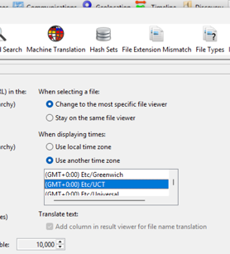  - In Autopsy, go to Tools > Options > Timezone  - Confirmed GMT+00:00 UTC is selected
Recover lost folders  (NTFS, FAT16&32). | Yes | 30/12/2025 | 6:25 AM | 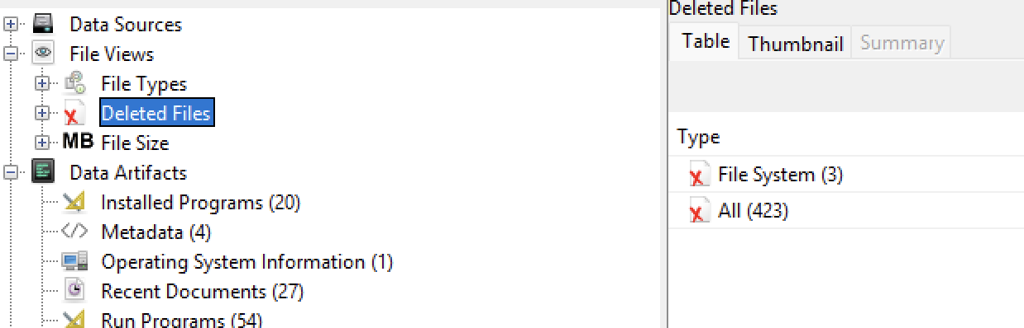  check Views > File Types > Deleted
Mount archives;  zip, thumbs.db, etc. | Yes | 30/12/2025 | 7:00 AM | - Go to Data Artifacts > File Types > Archives  - Filter .zip, .rar, .thumbs.db  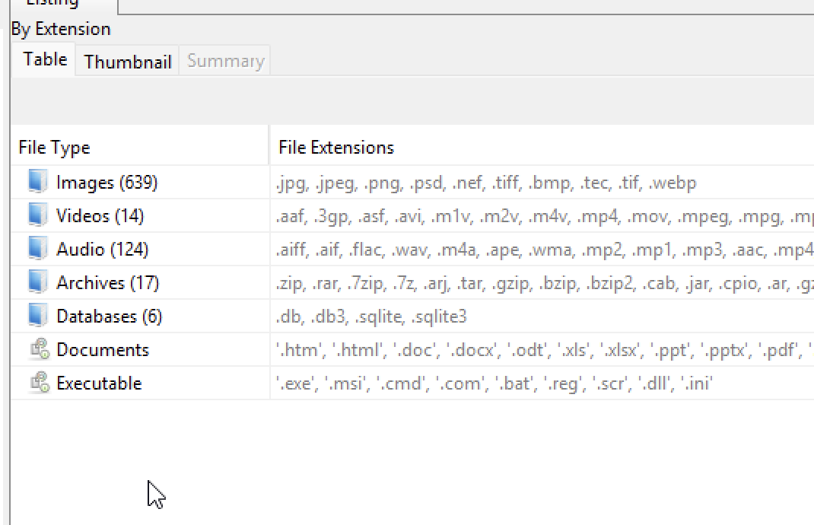
File signature analysis (any interesting file mismatch?);  Compute hash values (enable entropy computation) | Yes | 30/12/2025 | 7:30 AM | 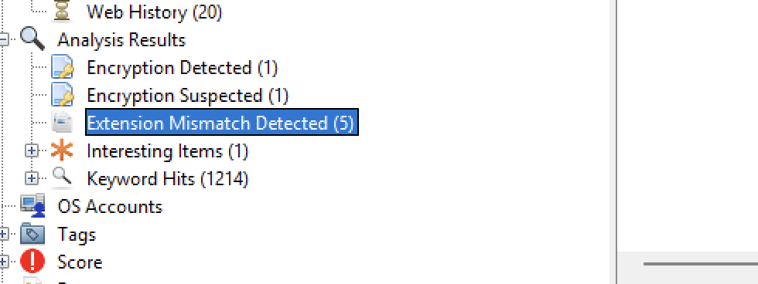  Go to Analysis Results> Extension Mismatch Detector
Internet History, favourites, etc.  Other browsers? | Yes | 30/12/2025 | 7:45 AM | - Go to Data Artifacts > Web History  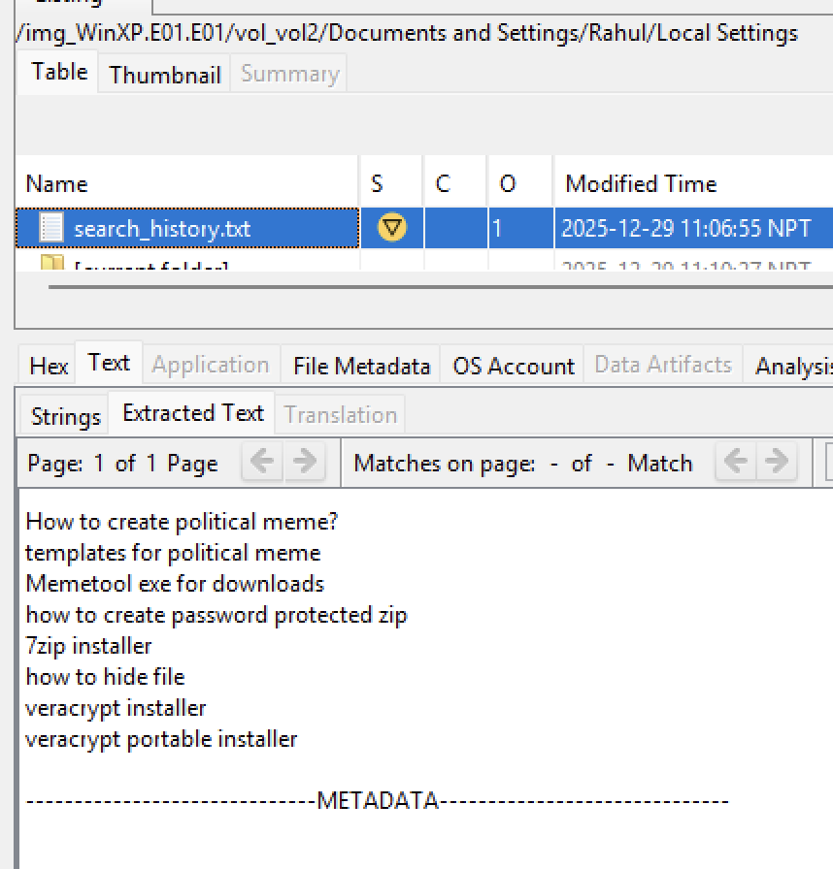  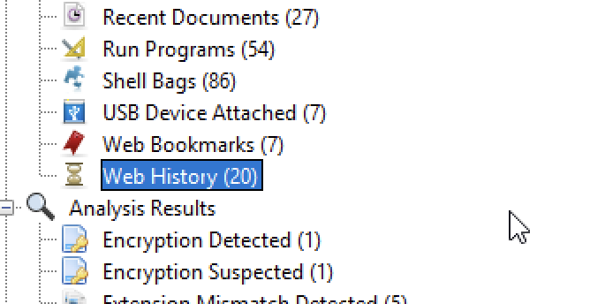  - path: /documents and settings/ Rahul/localsettings
Emails, local and web-based. | Yes | 30/12/2025 | 8:00 AM | no emails found
Retrieve operating system information, accounts information, software, time zone information etc.). | Yes | 30/12/2025 | 9:00 AM | - Open SYSTEM, SAM, SOFTWARE, security hives from Data Artifacts  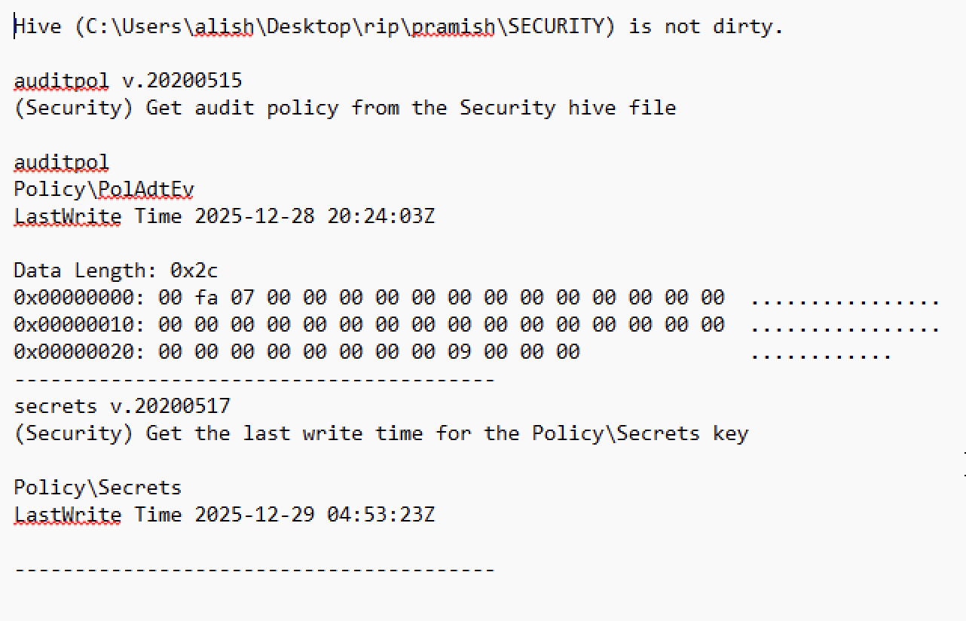  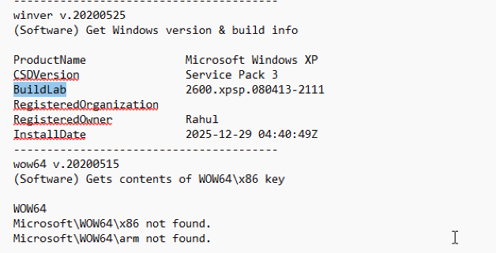  - path: "/WINDOWS/system32/config"  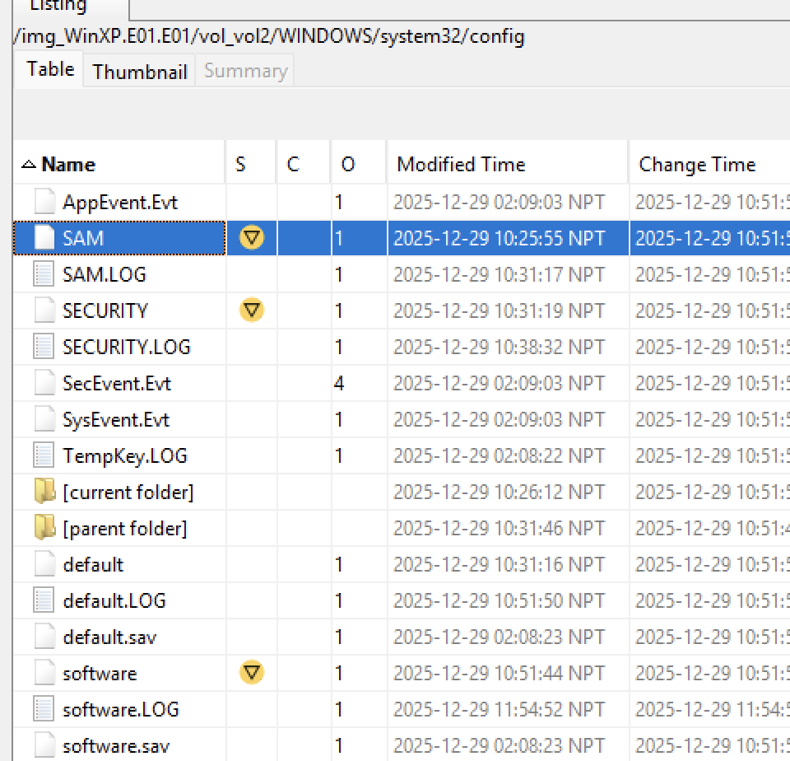  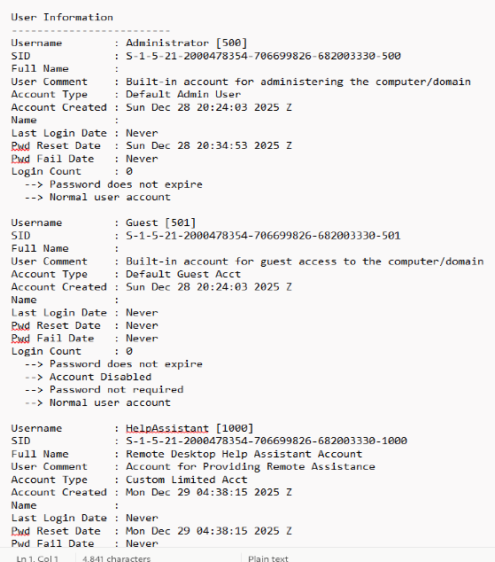  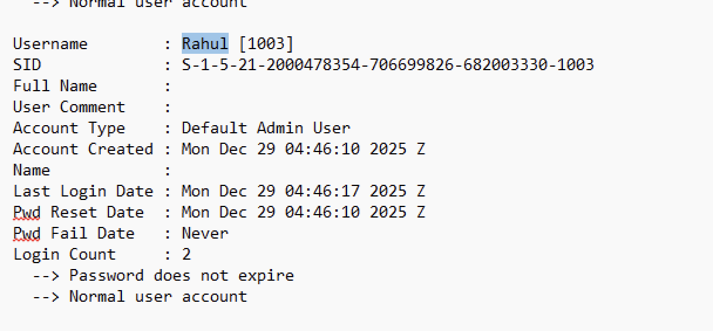  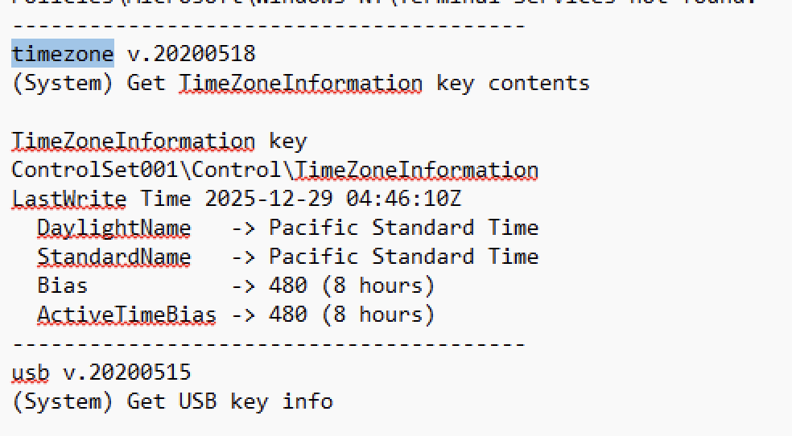  - SAM hive was analyzed, the username is “Rahul ”  - No password is required to access the user.  - SYSTEM hive was analyzed, the timezone of the device is GMT.  The SOFTWARE hive was analyzed, the OS of the device is Windows XP.
Timeline analysis-  Note date of last activity on the computer. System profiling. | Yes | 30/12/2025 | 10:00 am | 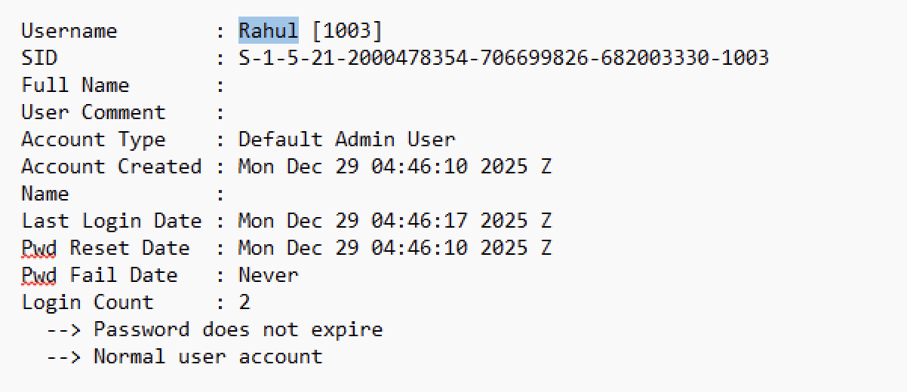  Last logon date: mon dec29 04:46:10 2025
Registry analysis and  Registry protected area | Yes | 30/12/2025 | 11:30 am | - SAM, SYSTEM , SECURITY and SOFTWARE hives have already been analyzed.  - Utilized RegRipper to analyze the extracted registry hives.  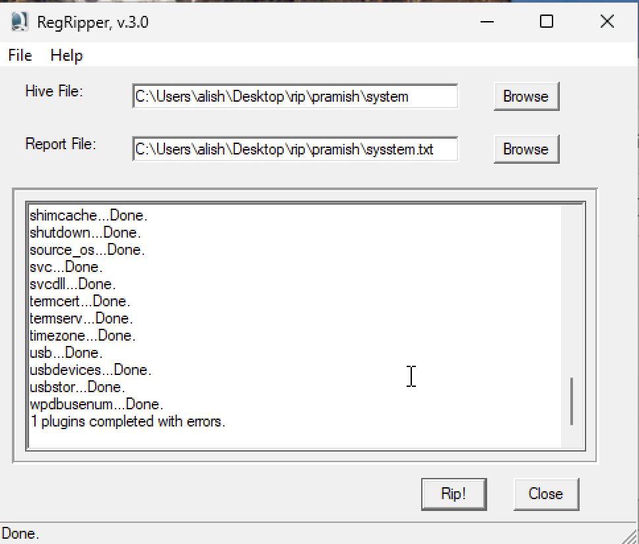
Link files and Recycle Bin | Yes | 30/12/2025 | 12:00 pm | - Data Artifacts > Recycle Bin, Recent Documents  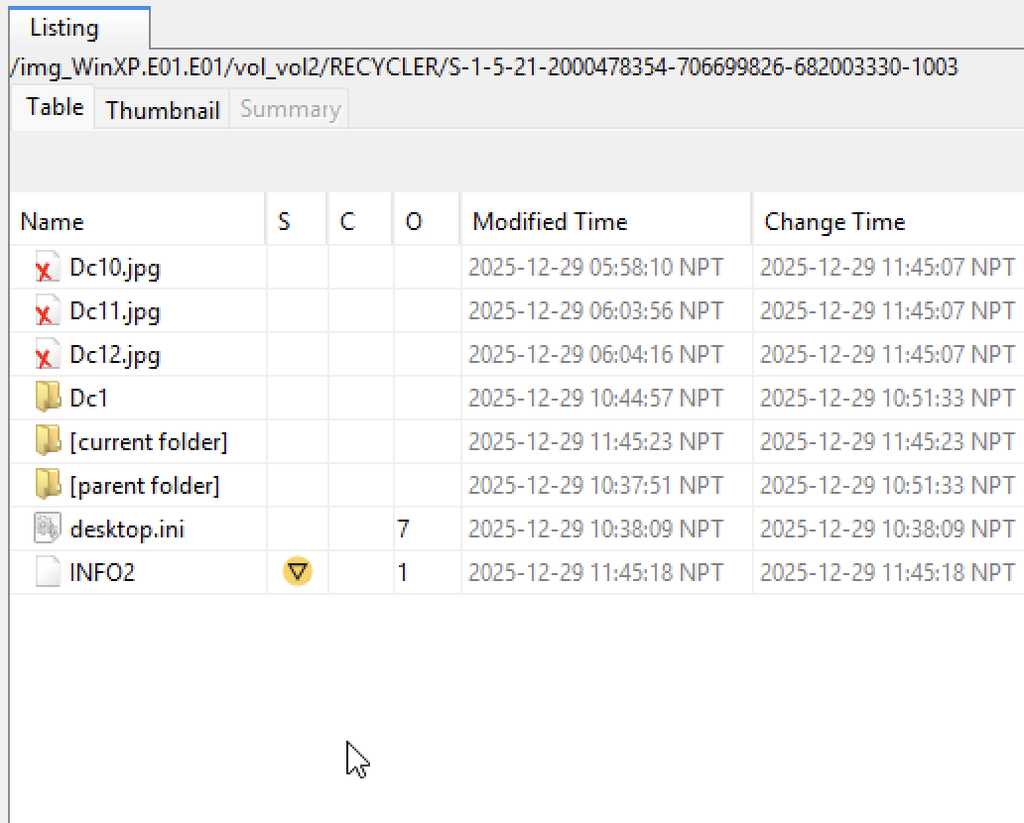  - Data Artifacts > Recent Documents  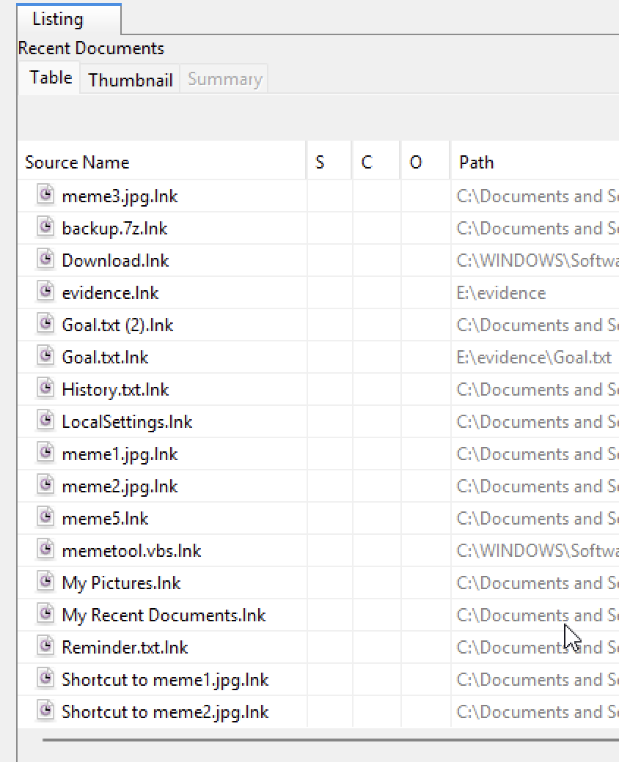
Instant Messaging clients | Yes | 30/12/2025 | 1: 00 pm | - Data Artifacts > Installed Programs  Email client outlookexpress was found  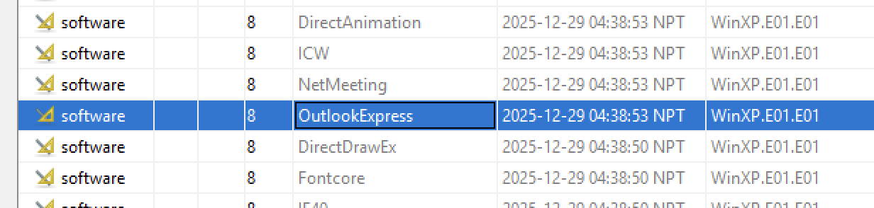
Clean-up/Wiping utilities. Check log files. Anything used? | Yes | 30/12/2025 | 2:00 pm | - Data Artifacts > Run Programs  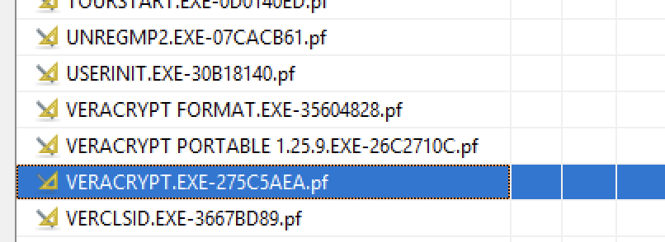  Veracrpyt was seen
External drives; Network connections | Yes | 30/12/2025 | 2:30 pm | 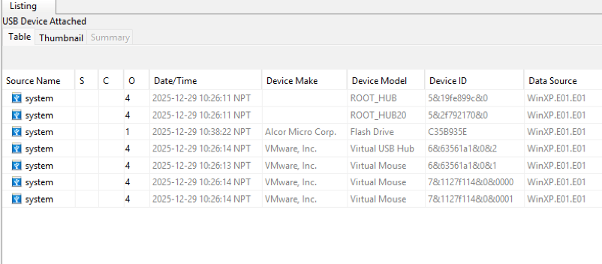  - Data Artifacts > USB Device Attached
Perform data carving | Yes | 30/12/2025 | 3:00 pm | 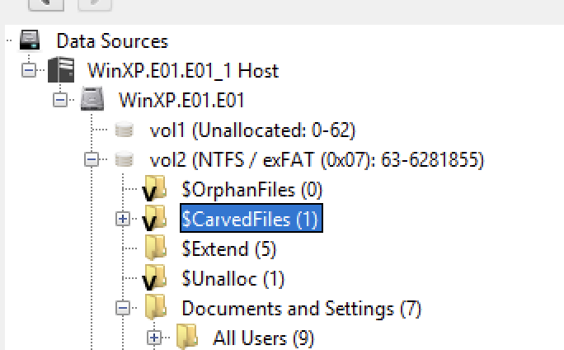  Run PhotoRec Carver module > Carved Files
Run relevant keyword searches;  Did you index the evidence file? | Yes | 30/12/2025 | 3:15 pm | 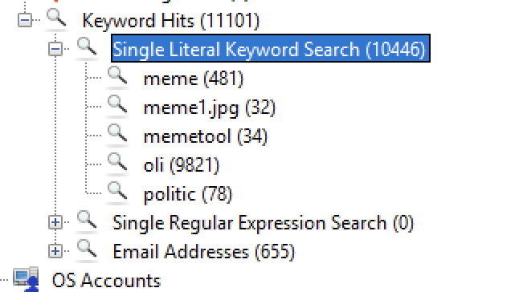  Reviewed the results under "Analysis Results > Keyword Hits > Single Literal Keyword Search."
Recover Log-on passwords –  use SAMInside/Ophcrack/Encase | Yes | 30/12/2025 | 3:45 pm | - SAM file was previously analyzed. No password is required for the login.  - One image was found related to password  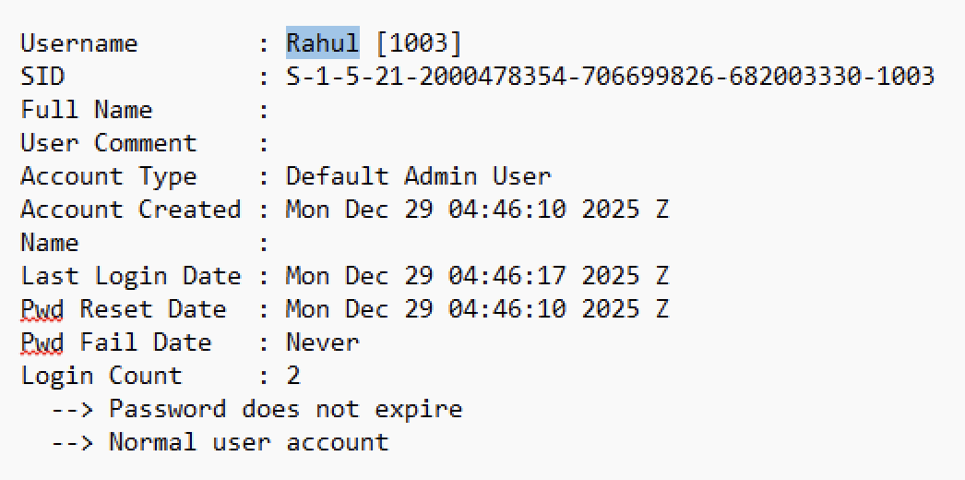  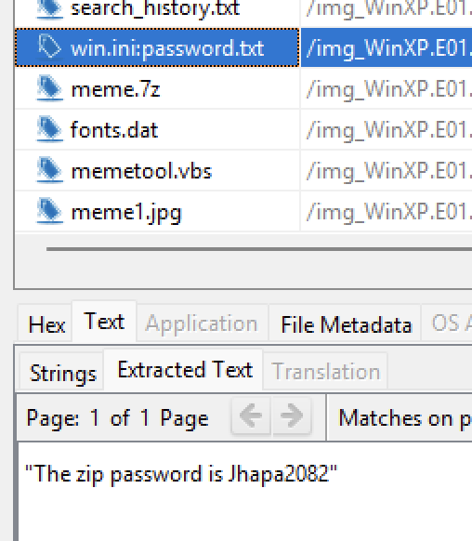
Examine different file types:  Export doc/office and exe files; look at Metadata if required | Yes | 30/12/2025 | 4:00 pm | - File Types > Metadata  - Metadata of Multiple images were analysed.  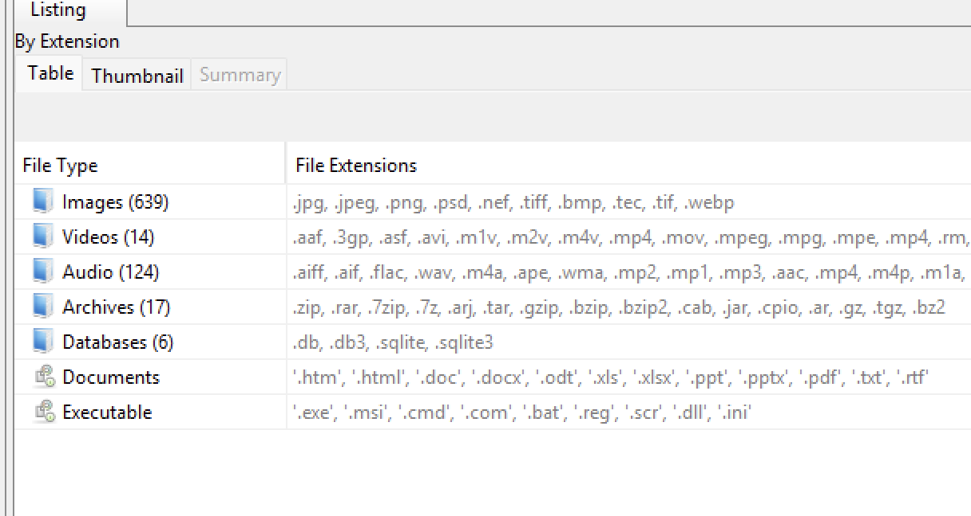  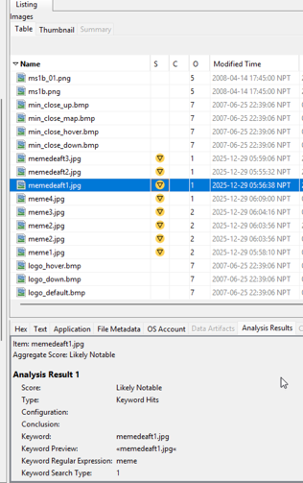
Encryption, Steganalysis (any indications? Entropy or Autopsy can be used) | Yes | 30/12/2025 | 4:30 pm | - Click: Analysis Reports> Encryption Detected  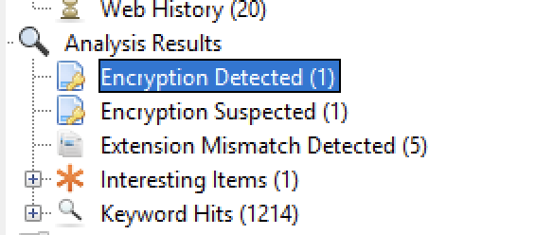  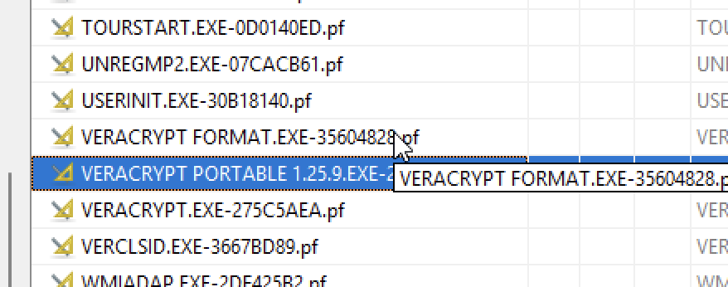
Print artefacts | Yes | 30/12/2025 | 4:45 pm | - Investigated /Windows/System32/spool/PRINTERS/ and searched entire image for .spl and .shd files.  No evidence of print spool files found.  - Keyword searches for printer, .spl, and spool returned 0 relevant hits.  - Also reviewed system.evtx log for PrintService events — none were recorded.  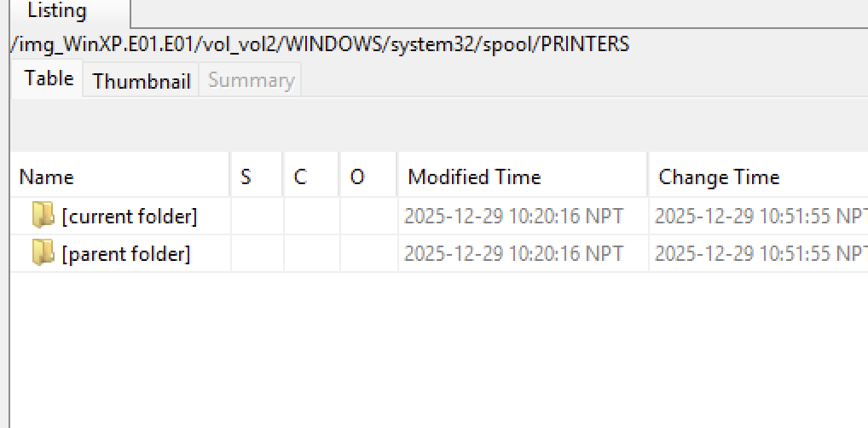
CD/DVD burning apps; check log files | Yes | 30/12/2025 | 4:50 pm | 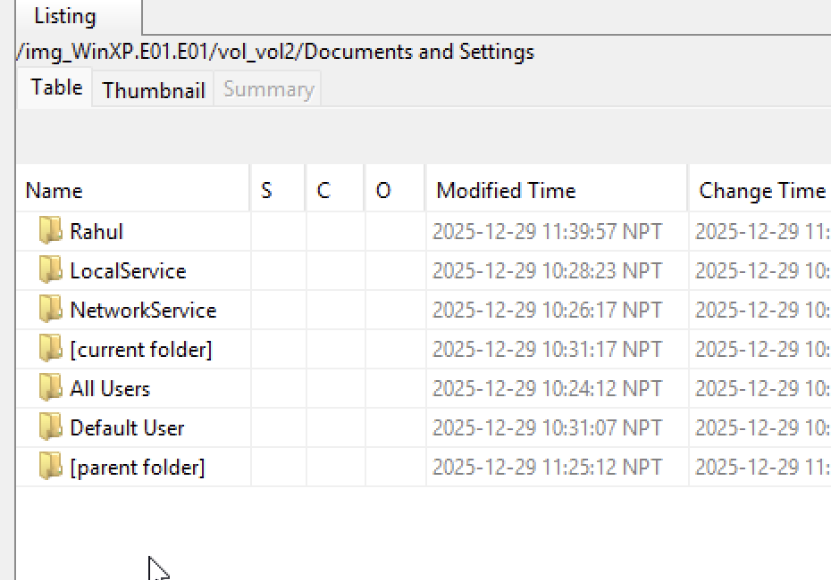  - Analysed Path: /Documents and Settings/
Validate evidence integrity at the end of the examination | Yes | 30/12/2025 | 9: 00 pm | - Hash values are consistent, indicating an examination conducted without data tampering.  - Ran the Ingest module to verify Data Source Integrity.

Additional Notes/Artefacts Examined:

Colour-coding Legend | Tasks
 | Fundamental
 | Basic
 | Elementary
 | Secondary
 | Advanced
 | Exceptional

